AI FitTrack Final Project Report
  - Phase 7

This final report presents the complete backend project from problem definition through architecture, implementation, API design, security, Gemini integration, testing, outcomes and submission requirements.
Field | Value
Project | AI FitTrack
Submission | SmartBridge Naan Mudhalvan
Project scope | Backend-only REST API
Technology | Node.js, Express.js, MongoDB, Mongoose, JWT and Google Gemini AI
Source baseline | Latest uploaded backend ZIP and supplied verification evidence
Document status | Submission-ready content; student metadata and final video links remain pending

Prepared for academic evaluation. Secrets, credentials, private environment files and unverified claims are excluded.

Document contents
1. Abstract and project overview
2. Problem statement and objectives
3. Requirements and scope
4. System design
5. Database and API specification
6. Implementation
7. Security and AI controls
8. Testing and results
9. Limitations and future scope
10. Conclusion
11. Appendices

Abstract
AI FitTrack is a secure backend REST API for personal workout tracking and AI-assisted fitness guidance. It is implemented with Node.js, Express.js, MongoDB, Mongoose, JSON Web Tokens, bcrypt and Google Gemini AI. Authenticated users can maintain an owner-isolated workout history, search that history and request structured recommendations or progress insights. The supplied evidence records successful live authentication, CRUD, search and Gemini flows together with 95 automated passes, 17 smoke checks and 19 Atlas checks. The project is backend-only and is ready for integration with a future web or mobile client.

1 Introduction

1.1 Problem statement
Manual workout notes are difficult to search, update and protect. They also provide little support for turning basic exercise history into practical guidance. AI FitTrack addresses those needs through a centralized, authenticated API rather than a user-interface-specific implementation.
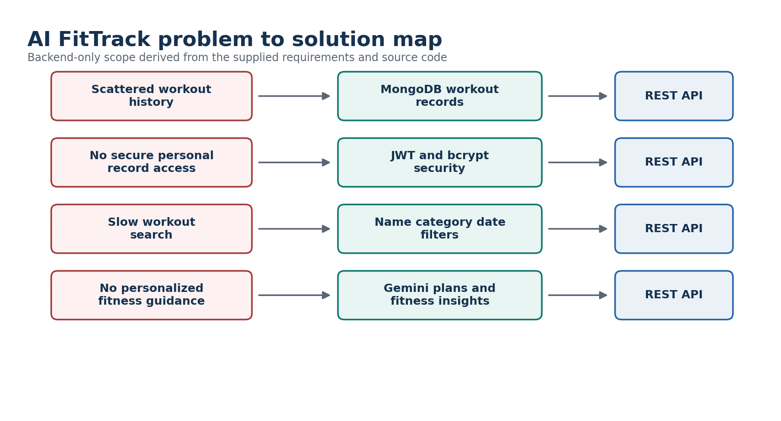
Figure 1 Problem to solution mapping

1.2 Objectives
- Protect personal fitness data through secure authentication and owner-scoped queries.
- Provide complete workout creation, retrieval, update, deletion and search functions.
- Use validated MongoDB documents for reliable workout history.
- Use Gemini to create structured recommendations and interpret workout statistics.
- Expose stable JSON contracts for later frontend or mobile integration.
- Handle invalid input, unknown routes, database failures and AI failures predictably.

1.3 Scope
Included scope comprises server configuration, database access, authentication, profile retrieval, workout CRUD and search, Gemini recommendation and insights, centralized validation and errors, tests and Postman assets. A React frontend, nutrition features, wearables, reminders and production deployment are outside this backend-only submission.

2 Requirement Analysis
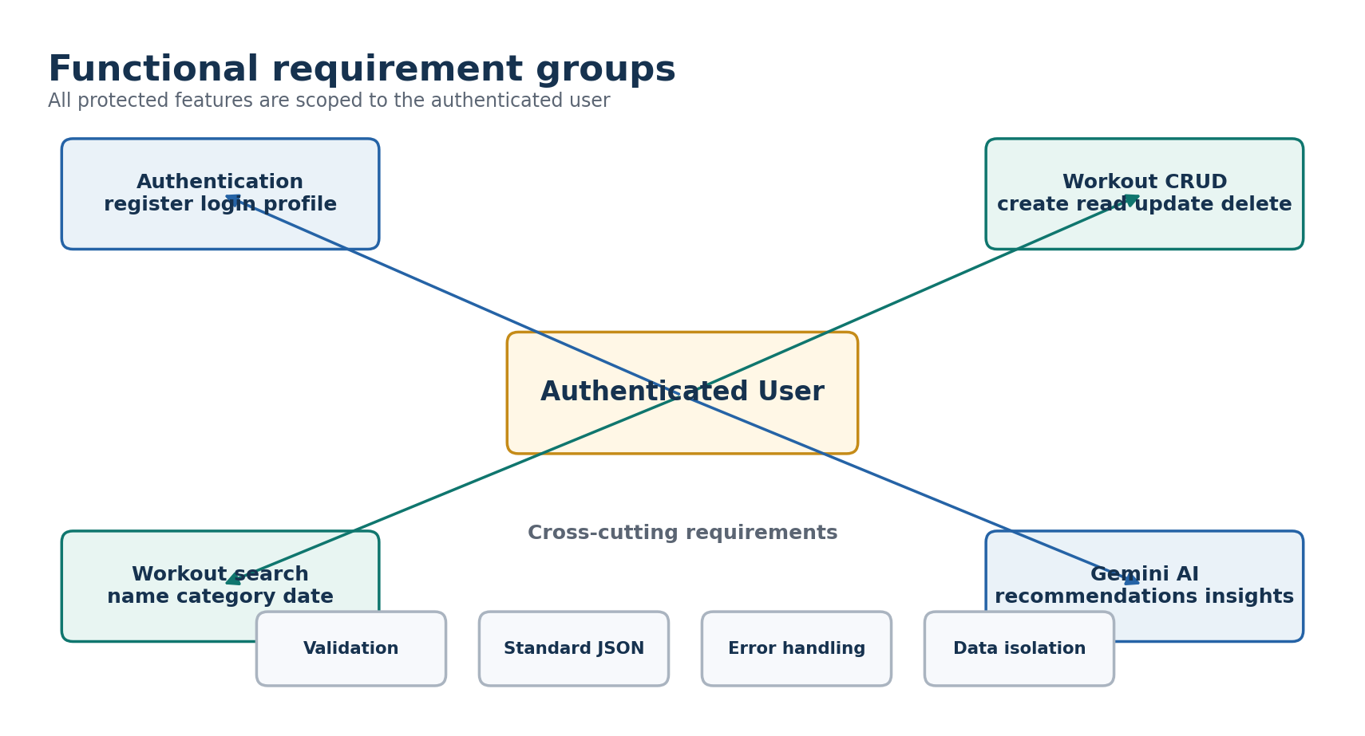
Figure 2 Functional requirement groups
ID | Requirement | Verified status
R1 | Layered MVC-style backend with routes, controllers, models, middleware, services and config | Implemented
R2 | Node.js and Express.js REST API | Implemented
R3 | MongoDB and Mongoose connection management | Implemented
R4 | Users and workouts collections | Implemented
R5 | User schema with validation, unique email, bcrypt and timestamps | Implemented
R6 | Workout schema with owner, fields, validation and timestamps | Implemented
R7 | User registration and duplicate handling | Implemented and live-evidenced
R8 | User login and JWT issuance | Implemented and live-evidenced
R9 | Protected user profile | Implemented and live-evidenced
R10 | Create owner-scoped workout | Implemented and live-evidenced
R11 | List workout history | Implemented and live-evidenced
R12 | Search by name, category and date | Implemented and live-evidenced
R13 | Get workout by identifier | Implemented and live-evidenced
R14 | Partial workout update | Implemented and live-evidenced
R15 | Delete workout and deny later retrieval | Implemented and live-evidenced
R16 | Gemini workout recommendation | Implemented and live-evidenced
R17 | Gemini fitness insights using submitted or database statistics | Implemented and live-evidenced
R18 | Standard JSON responses and centralized error handling | Implemented
R19 | Request and schema validation | Implemented and automated-test evidenced
R20 | JWT middleware and fresh user lookup | Implemented and automated-test evidenced
R21 | Password protection and response redaction | Implemented and live-evidenced
R22 | Per-user data isolation | Implemented and automated-test evidenced
R23 | Postman, automated, smoke and Atlas verification | Evidence supplied
R24 | Environment-based MongoDB, JWT and Gemini configuration | Implemented with example only

2.1 Nonfunctional requirements
- Security through hashing, JWT verification, owner isolation, safe serialization and private environment values.
- Maintainability through modular routes, controllers, models, middleware, services, configuration and utilities.
- Reliability through database-gated startup, centralized errors, AI timeouts and bounded retries.
- Interoperability through HTTP, JSON, CORS and documented API contracts.
- Testability through validation units, Supertest integration, memory MongoDB, smoke scripts, Atlas scripts and Postman.

3 System Design
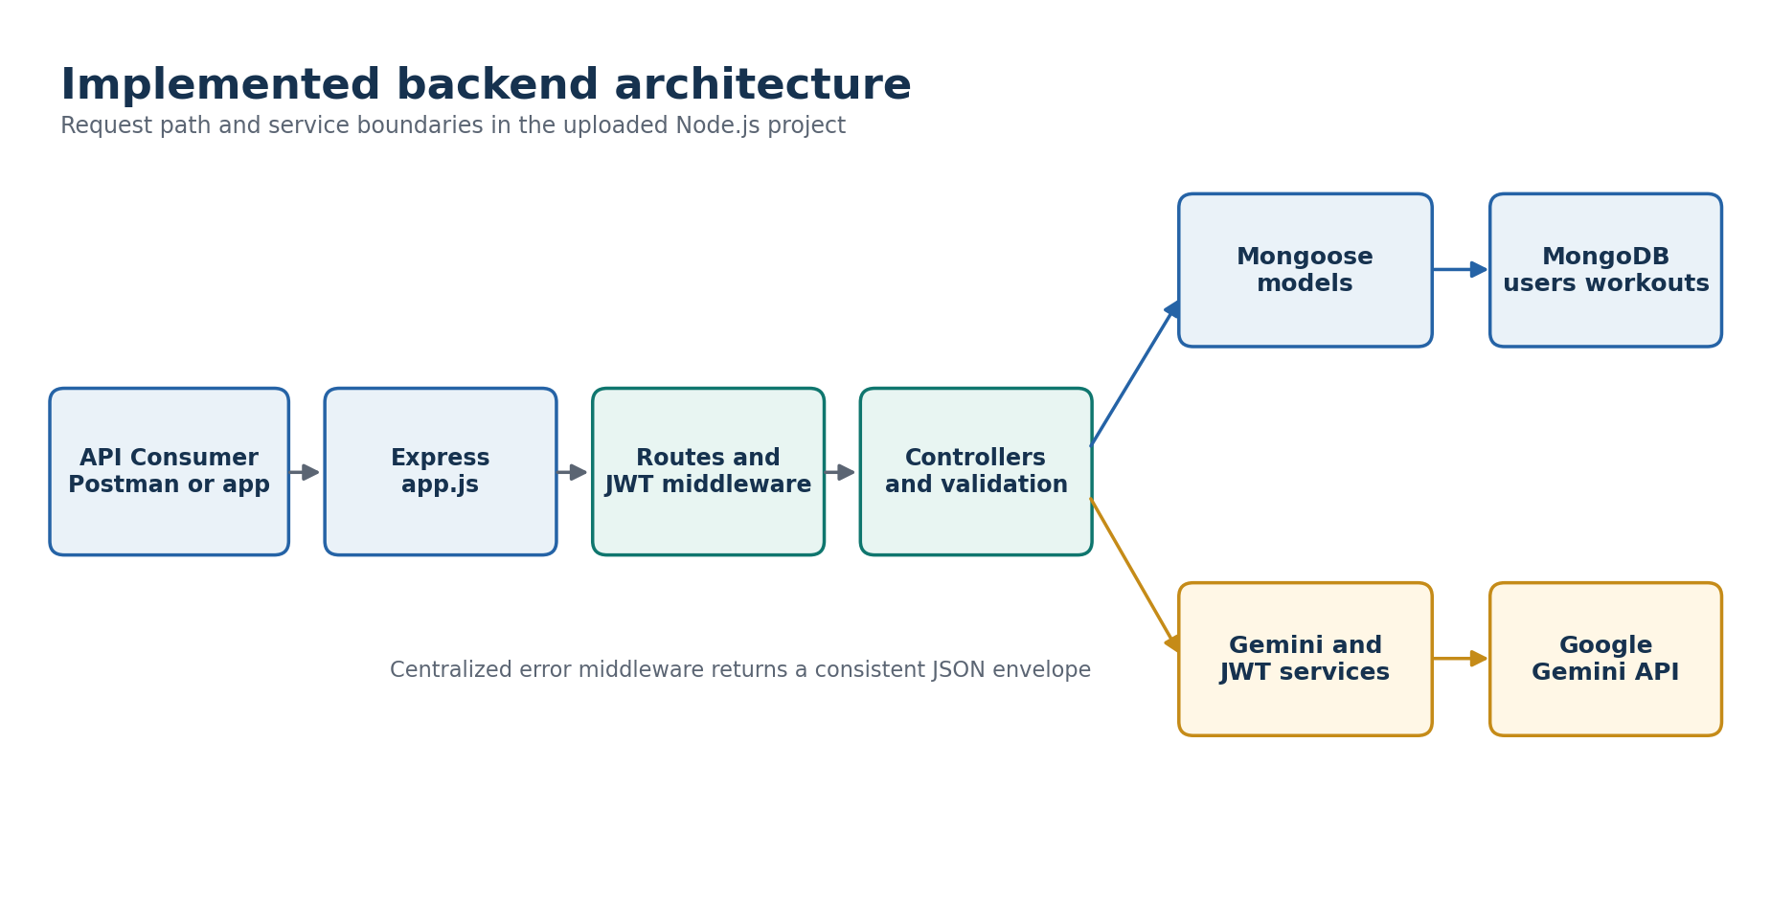
Figure 3 Implemented layered backend architecture
The Express gateway receives the request and applies common middleware. Feature routes select a controller and enforce JWT protection where needed. Controllers call validation utilities, Mongoose models and services. MongoDB stores users and workouts; Google Gemini provides structured AI output. The centralized error middleware converts failures into a consistent JSON envelope.

3.1 Request sequence
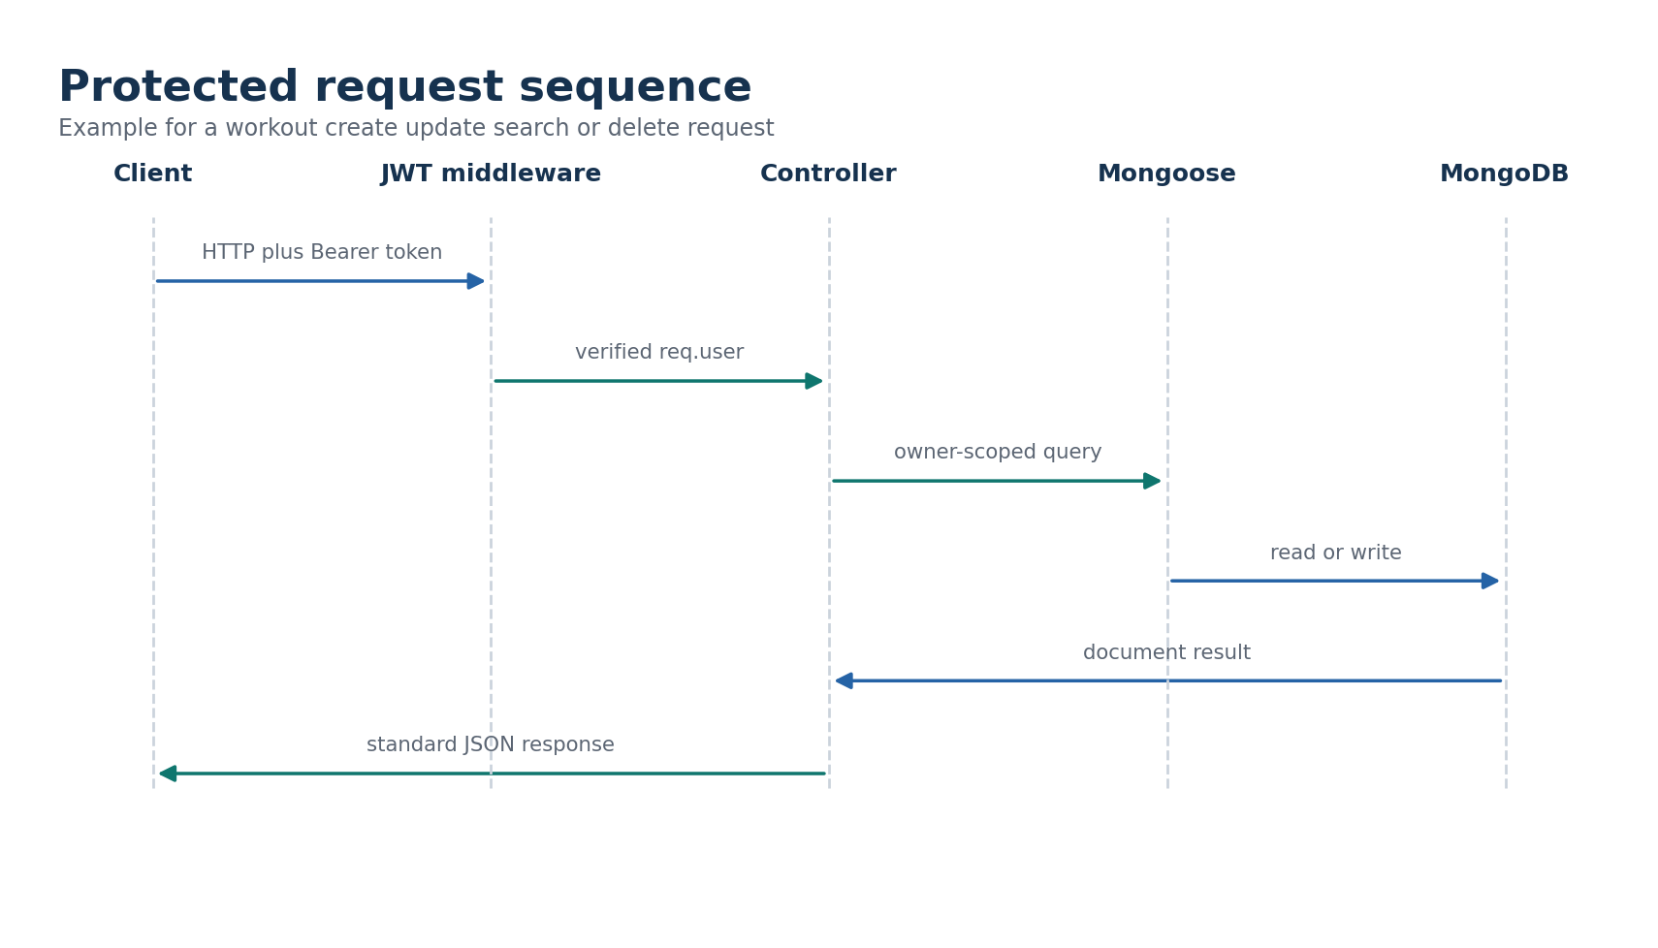
Figure 4 Protected owner-scoped request sequence

3.2 Component responsibilities
Component | Responsibility
server.js | Validate JWT configuration, connect MongoDB, start HTTP listener and shut down safely.
app.js | Configure CORS and parsers, expose health, mount routes and register error handlers.
auth module | Register, login, profile and public email availability.
workout module | Owner-scoped CRUD, history ordering and search.
AI module | Recommendation, insights, rate limit and provider failure mapping.
models | Schema validation, indexes, password hook and safe JSON output.
services | Centralized JWT behavior and structured Gemini generation.
tests and Postman | Automated and guided verification assets.

4 Database Design
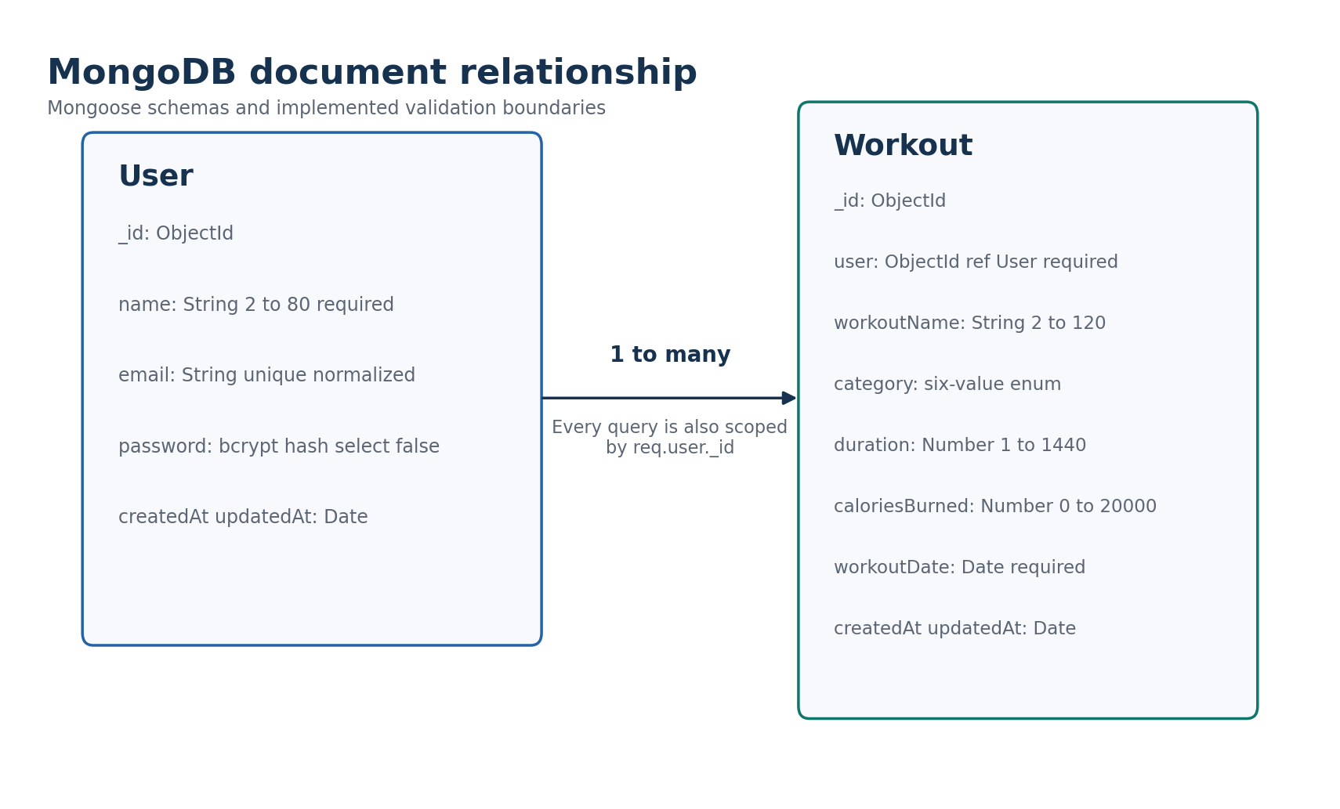
Figure 5 MongoDB collections and relationship
A user owns zero or more workouts. The relationship is stored in Workout.user as a required ObjectId reference. Queries always add the authenticated user's identifier, which avoids relying on a user id in the request body.
Collection | Important constraints | Indexes
users | Validated unique normalized email; bcrypt password; timestamps; password excluded from standard selection | Unique email index
workouts | Required owner, name, category, duration, calories and date; timestamps | user plus workoutDate plus createdAt; user plus category

5 API Specification
Method | Endpoint | Access | Purpose | Main statuses
GET | /api/health | Public | Service health and runtime metadata | 200
POST | /api/auth/register | Public | Create user and issue JWT | 201, 400, 409
POST | /api/auth/login | Public | Verify credentials and issue JWT | 200, 400, 401
GET | /api/auth/email-available | Public | Check normalized email availability | 200, 400
GET | /api/auth/profile | JWT | Return authenticated user profile | 200, 401
POST | /api/workouts | JWT | Create an owner-scoped workout | 201, 400, 401
GET | /api/workouts | JWT | List history and optional filters | 200, 400, 401
GET | /api/workouts/search | JWT | Search by name, category or UTC date | 200, 400, 401
GET | /api/workouts/:id | JWT | Read one owned workout | 200, 400, 404
PUT | /api/workouts/:id | JWT | Update allowed workout fields | 200, 400, 404
DELETE | /api/workouts/:id | JWT | Delete one owned workout | 200, 400, 404
POST | /api/ai/workout-recommendation | JWT | Generate structured workout plan | 200, 400, 429, 5xx
POST | /api/ai/fitness-insights | JWT | Generate submitted or database-derived insights | 200, 400, 429, 5xx

5.1 Request examples
POST /api/auth/register
{
"name": "Demo User",
"email": "demo@example.com",
"password": "<private value>"
}
POST /api/workouts
Authorization: Bearer <token>
{
"workoutName": "Morning Run",
"category": "Running",
"duration": 30,
"caloriesBurned": 280,
"workoutDate": "2026-09-20"
}
POST /api/ai/workout-recommendation
Authorization: Bearer <token>
{
"age": 22,
"fitnessGoal": "Weight Loss",
"experienceLevel": "Beginner"
}
POST /api/ai/fitness-insights
Authorization: Bearer <token>
{ "useDatabaseStats": true }

5.2 Response design
Successful responses include success, message and data. Errors include success false, a human-readable message and an errors array. AI operational failures may additionally include a safe code, attempt count and retryAfterSeconds.

6 Implementation
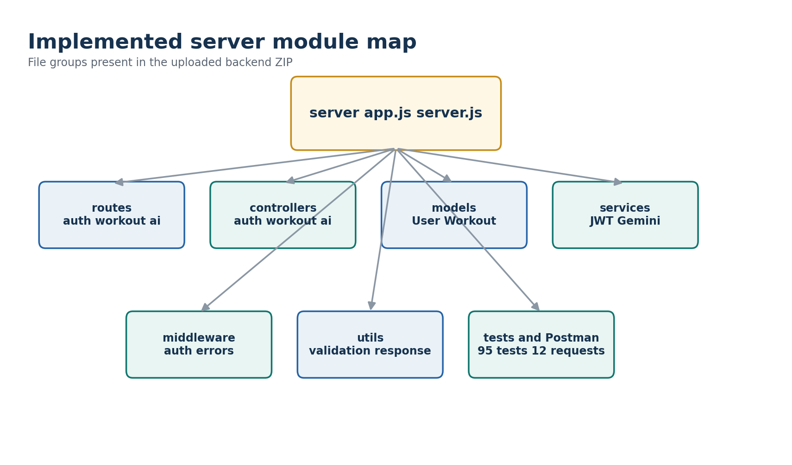
Figure 6 Implemented source modules
The project is packaged as a private Node.js module named ai-fittrack-api. The server uses Express 5 and Mongoose 9 and declares Node.js 20 or later. package-lock.json supports reproducible installation. No private .env file is included.

6.1 Authentication
User passwords are hashed before storage. Registration and login return safe user fields and a signed JWT. Protected middleware accepts only Bearer tokens, verifies the issuer and signature, checks the identifier and reloads the user. A deleted or unknown user therefore cannot keep using an old token.

6.2 Workout management
Workout validation is performed before model operations, and the model provides a second validation boundary. Listing is ordered by workout date and creation time. Search supports an escaped partial name, canonical category, valid UTC calendar date and a result limit clamped to 1-500.

6.3 Gemini AI
Gemini prompts explicitly restrict the model to general fitness guidance and instruct it not to assume medical conditions or create extreme programs. Response schemas make the output predictable for clients. The service handles timeouts, quota pressure, unavailable services, bad keys, model errors and malformed output.

7 Security and Reliability
Control | Implementation
Password storage | bcrypt with cost 12; password excluded from normal model selection and serialized output.
Token validation | JWT secret required, issuer checked, expiry supported and active user reloaded.
Data isolation | Every workout query is owner-scoped by req.user._id.
Input safety | Allow-lists, numeric boundaries, ObjectId checks, regex escaping and malformed JSON handling.
CORS | Origins are derived from CLIENT_URL; unauthorized browser origins receive 403.
AI resilience | Timeout, bounded retry, Retry-After support, safe error mapping and per-user request limit.
Secret handling | Only .env.example is included; private values are loaded locally.
Operational behavior | Database connection must succeed before listen; SIGINT and SIGTERM close services.

8 Testing and Results
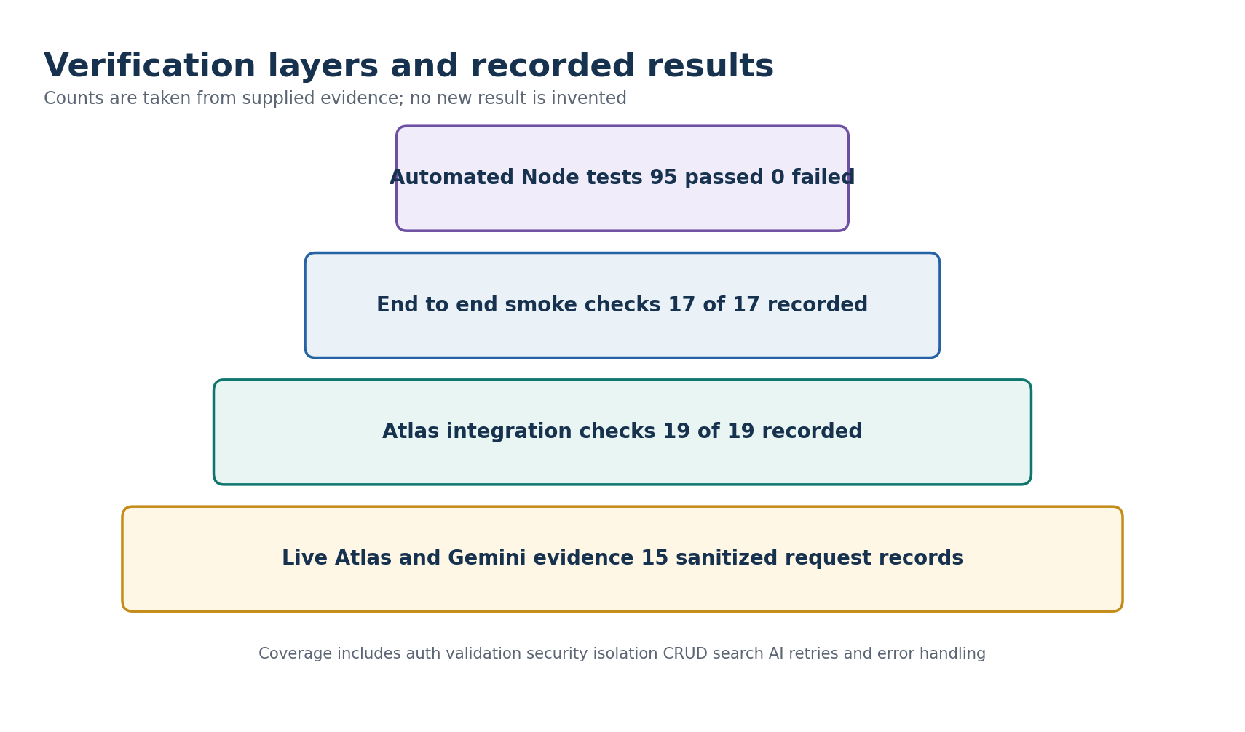
Figure 7 Recorded verification layers
Test file | Cases | Coverage
ai.test.js | 23 | AI validation, structured responses, database stats, failures, rate limiting and regression
auth.test.js | 23 | Registration, login, profile, token failures, duplicate and password behavior
geminiRetry.test.js | 13 | Transient retries, Retry-After, bounded backoff, non-retryable failures and parsing
security.test.js | 8 | CORS, ownership, secret handling, password exposure and security boundaries
validation.test.js | 16 | Authentication, workout and AI input normalization and validation
workouts.test.js | 12 | CRUD, search, ordering, isolation, validation and UTC date behavior
Total | 95 | Recorded automated run: 95 passed and 0 failed

8.1 Live result highlights
- Registration returned 201 with a token and safe user fields; the password hash did not appear.
- Login and authorized profile returned 200; profile without a token returned 401.
- Workout create, list, retrieve, update, name search, category search, date search and delete succeeded; follow-up retrieval after delete returned 404.
- The recommendation endpoint returned a structured seven-day Gemini result for a beginner weight-loss profile.
- Database insights computed 3 workouts, a 38.3-minute average and 780 calories exactly from three temporary owner records.
- Temporary evidence users and workouts were removed after the verification flows according to the supplied cleanup records.

8.2 Evidence qualification
The live evidence is sanitized text, not a collection of screenshots. It also contains two response-shape differences from the uploaded source: the recorded delete payload is null whereas the current controller returns the deleted workout, and the submitted-statistics source label is recorded as manual whereas the current controller uses submitted. These do not invalidate the verified features, but the exact current responses should be re-captured from the final GitHub commit.

9 Outcomes Limitations and Future Scope

9.1 Outcomes
The project delivers the required backend capabilities with clear separation of concerns, secure owner isolation, structured AI output and a substantial verification suite. The response contracts are suitable for a future browser or mobile client.

9.2 Current limitations
- No user interface is included in this backend-only submission.
- The in-process AI rate-limit map is not shared across multiple server instances.
- There is no refresh-token or token-revocation store.
- Workout lists use a bounded limit but do not implement cursor pagination.
- Gemini guidance is general fitness information and is not medical advice.
- A public deployment URL and final video URL have not been supplied.

9.3 Future enhancements
- Frontend dashboard with accessible charts and workout forms.
- Pagination, sorting options and aggregated progress endpoints.
- Distributed rate limiting and structured operational telemetry.
- Refresh-token rotation, account recovery and configurable role support.
- Nutrition, BMI, reminders and wearable integration after separate privacy review.

10 Conclusion
AI FitTrack meets the official backend objectives with secure authentication, MongoDB workout management, search and Gemini-assisted guidance. The implementation and supplied evidence support the functional completion claim. Final submission readiness depends on adding official student metadata, publishing the repository, capturing synchronized final evidence and recording the demonstration video.

Appendix A Source and evidence register
Artifact | Use in this report
AI-FitTrack-backend(1).zip | Authoritative uploaded source baseline.
AI FitTrack(5).docx | Official project description, architecture, schemas, features and execution requirements.
AI-FitTrack-submission-evidence.zip | Sanitized live auth, workout and Gemini records plus requirements and README verification.
server/tests/*.test.js | 95 present automated test definitions across six files.
AI-FitTrack.postman_collection.json | 12 ordered manual requests.

Appendix B Safe local configuration checklist
- Create server/.env locally from server/.env.example.
- Use a long random JWT_SECRET and a restricted MongoDB account.
- Restrict Atlas network access rather than leaving an unrestricted rule permanently.
- Keep GEMINI_API_KEY server-side and rotate it if it is ever exposed.
- Verify git status and repository history contain no private environment file.

Items requiring student confirmation
Pending item | What to provide
Student identity | Name, NM ID, register or roll number and department were not present in the supplied project files.
Institution details | College name, academic year, guide or mentor name and official submission date need confirmation.
Team details | Team name, member list and responsibility allocation were not supplied; no ownership is assigned in these documents.
Repository | Insert the final public GitHub repository URL after upload.
Deployment | Insert the deployed API base URL if the evaluator requires a hosted demonstration.
Demonstration video | Record the video using Phase 8 and insert the final shareable video URL.

